Benjamin Reed, Hayden O'Reilly, Manolo Ortiz

Spectral Forest User Manual

Spectral Forest User Manual & Report
Table of Contents
Minimum Hardware / Software Requirements: 2
How to Operate the System 3
How to Maintain & Improve the System 4
System Features and their Functionality 4
Introduction 6
Problem Statement 6
Needs 6
Objective 6
Marketing Requirements 6
Concept 7
Project Management 11
Work Breakdown Structure 11
Gantt Chart 13
PERT Chart 15
Testing 16
Test Matrix 20
Conclusion 21
References 22

Minimum Hardware / Software Requirements:
- To first begin, the user is assumed to have a running Linux-based system with sudo privileges:
  - In Linux, log in as root:
    - <sudo -i> To log in as root in a terminal of your choice.
  - Then type:
    - <usermod -a -G dialout “username”>, Enter username without quotes.
  - Then enter:
    - <sudo reboot> This will initiate the user privileges for using the program screen.
  - In a terminal window:
    - Enter <screen>
    - If the program has been installed you are good to go. If not, follow the prompt to install the screen program.
  - In terminal window:
    - Enter <nano ~/.bashrc>
    - Under ‘some more aliases’:
      - Enter <alias run_pyboard=’screen /dev/ttyACM0’>
    - Save and close file. Close terminal.
    - Open terminal:
    - Enter <alias> verify newly created alias.

How to Operate the System
- In terminal window:
  - Enter <run_pyboard>:
    - Note: ensure PYBOARD SD is connected to machine and alias was created.
- User password:
  - Enter the user password:
    - <spectral>
    - Then press <Enter>. Default password is User can change the password by entering selected password on main.py at the top of the script under password.
- Clearing files: To clear all files:
  - Enter <yes>
  - Otherwise press <Enter> to keep files. Note all files will be deleted on path “/sd/Spectral_Forest_Data”. Path can be changed on main.py under path at the top of the script.
- Auto Integration:
  - User can select auto integration by entering <yes>. To manually select integration, press enter. User will be ported to select integration value from 1 to 9. 1 is the lowest integration time(us) and 9 is fastest integration time(us).
- Sample number:
  - Enter the total number of samples to be captured. Value should be 2 or more.
- Sample interval:
  - Enter the interval time between samples in minutes. Value should be 0.1 minutes or more. Note: this is the time the system will be in sleep mode (power saving mode).
- Date and Time update:
  - Enter <yes> To update time, otherwise press <Enter>. Note: if update is selected system will prompt user to enter 4-digit year, 2-digit month, 2-digit day, day of the week 1 for Monday 7 for Sunday, 2-digit hour in military time, 2-digit minute.
- The system will display the expected run time to complete all samples. Note: led light will blink violet to indicate a sample has been collected and system will go into sleep mode (low power mode).
- To wake the system from standby mode:
  - Insert USB into port. Note: System will reset.

How to Maintain & Improve the System
Take care when selecting the size of the SD card being used with the spectrometer. If the amount of data recorded during a single run causes the currently on-board card to run out of memory, the program will crash, as there is currently no failsafe for when there is no memory to store to. Be aware of the size of the card you choose to use when determining how many samples you want to take.
Should the responsivity of the spectrometer begin to diminish, the internal circuit board includes a trimmer potentiometer that can be used to manually adjust the gain of the output amplifier.
The spectrometer was unable to be extensively tested within an optical assembly under a known light source, so future calibrations will have to be performed by future project groups.
The timing parameters are tuned on a per-PyBoard basis. Because of the crystal oscillator that runs the on-board timer being slightly different between different PyBoards, as well as the varying nuances/tolerances of components between different PyBoards, the tuning of timing parameters may be required in the event of a PyBoard replacement or significant aging. This will also cause different copies of the same spectrometer to have slightly different timing parameters.

System Features and their Functionality
The TCD1304DG chip can detect wavelengths of light in the range of 400 nm to 1000 nm. The linear array produces numerical data based upon the light that is taken in and the time the data was recorded, which is stored in non-volatile memory on the spectrometer.
The spectrometer can operate on its own running off battery and solar power and does not require the user to be present while collecting data. The battery will automatically charge while the spectrometer runs off solar power or when it is plugged in via USB. Data can be safely collected from the SD card after a data collection run even if the spectrometer runs out of power during a run (Data will be stored after a hard reset of the spectrometer).
The spectrometer allows for multiple (9) levels of integration to select from to allow for specific application dependent on light level (A higher light intensity requires a lower integration time). The spectrometer also has a built-in auto integration function, which automatically sets the integration time of the linear array based on detected light intensity for each sample, should the user not be able to be present to monitor samples. This can be selected during startup.
The produced csv files are dynamically split up to avoid exceedingly large files, making them easier to work with. The files can be easily worked with to transfer the data into any format the user may want.

Spectral Forest Report

Introduction
The health and diversity of plants in a forest can be determined by the condition of the forest, which can also serve as an indication of plant diseases and fire hazards. However, traditional methods of measuring forest health can be cumbersome, time-consuming, and require significant labor. While there have been previous efforts made to observe the health of the forest canopy, the understory is often overlooked. This highlights the need for a system that can evaluate forest health with minimal effort and waiting time.
Our project seeks to utilize the measurement of wavelengths of light in determining various conditions of the health and well-being of the forest understory such as plant health, species differentiation, and subtle environmental changes specific to the understory. While other spectrometers exist on the market that can be used in a more “local” setting and can measure light in similar ways, our design hopes to be able to run for extended periods of time within more remote locations. Our team consists of Benjamin Reed (Team Lead), Manolo Ortiz (Treasurer), and Hayden O’Reilly (Secretary), working alongside Dr. Alexander Shenkin.

Problem Statement
Needs The condition and diversity of plants can be determined by the health of the forest, which can be indicators of plant disease and fire dangers. Measuring the health of forests using traditional methods can be a tedious, time-consuming, and labor-intensive process. There is a need for a system that can evaluate the health of forests that are less labor-intensive with minimal waiting time.
Objective The objective of this project is to create and test a device capable of assessing the overall health of forests. The device will allow researchers to capture and save spectral image wavelengths that can be used to determine the well-being of plants and trees. With remote data-capturing capabilities, the device will eliminate the need for physical presence during data collection.

Marketing Requirements
The system should be portable, durable, and operate in a remote location for a long period of time. It should be easy to use and be able to collect, store, and extract data. In addition, the device should have the capability to measure the visible light spectrum and optimize power consumption.

Concept
The concept is a scientifically calibrated spectrometer, capable of observing and recording data from the light brought in from the forest. The system can run off 3 different power sources: Solar, USB, and Battery, and can automatically switch between them for optimal energy usage using the BQ24074 power regulator, which also charges the battery when not in use. The system design is centered around an optical assembly, which will be able to focus graduated and columnated light (using a cosine corrector and specially fitted mirrors) into the linear array we are using to measure and record the spectral data, the Toshiba TCD1304DG chip (Direct light exposure would not work due to the dimensions of the Linear array). The system will run off the PyBoard v1.1 microcontroller, selected for its high processing power, which is responsible for obtaining, formatting, and outputting data from the linear array using Pulse Width Modulation (PWM), as well as powering most of the other components within the design. These components include additional sensors for monitoring the environment the system will be in to allow for insights on how it affects the data being collected, as well as several other components used to ensure the system is stable and running properly.
The PCB is custom made to fit the components used to ensure the TCD1304DG’s output is usable. Two boards are used, with one smaller board housing the linear array and environmental sensor, and the other housing the rest of the components. Each board will be connected via ribbon cables. Wi-Fi capabilities are a goal for the future, but may interfere with the design of the Mechanical Engineering team. A more robust user interface may be incorporated at a later time.
Over 700 lines of code were written for our design, with 25 different functions created from scratch for the purpose of ruinning the system. The additional 3V coin battery is situated for running the RTC so that the code would not output the incorrect time due to variations in the crystal oscillator. This code, in combination with the usage of the PyBoard, allows the program to run efficiently and communicate with the components effectively.
The above schematic shows the wiring and pinout of the PyBoard microcontroller, and the components hooked up to it. The system operates off a regulated 4.0VDC which is used to power the TCD1304DG linear array, the amplifier hooked up to the linear array’s output (so that the output signal is large enough to interpret), and the TI_SN74HC04N inverter used to invert the input signals for the linear array. Data from the Toshiba chip is transferred to the PyBoard and stored within a mounted storage device.
Using the data from the linear array, it is possible to make deductions based off the spectral wavelength responses recorded of the general wellbeing of the plant life within the forest and can be assessed under whichever conditions each data sample was taken at based upon readings from the environmental sensor within the system, the SHT31-D chip.
3 main groups of power are utilized – the 3.3V source for the PyBoard and SHT31-D, the 4V source for the TCD1304DG, which comes from the LP2985 low dropout voltage regulator, and the 5V boosted source for biasing the AD8027 amplifier circuit. A 3V coin battery is also used for the sole purpose of powering the Real Time Clock.
The AD8027 amplifier circuit is for boosting the output of the TCD1304DG to readable levels without saturating the data. This amplifier works in tandem with both the TPS61023 Boost Converter and the TPS6040x Charge Pump to produce a readable output. A 2k Ohm Trimmer Potentiometer is also incorporated to create an adjustable gain.
Below is the Bill of Materials used with the above schematic, including part numbers and manufacturers.
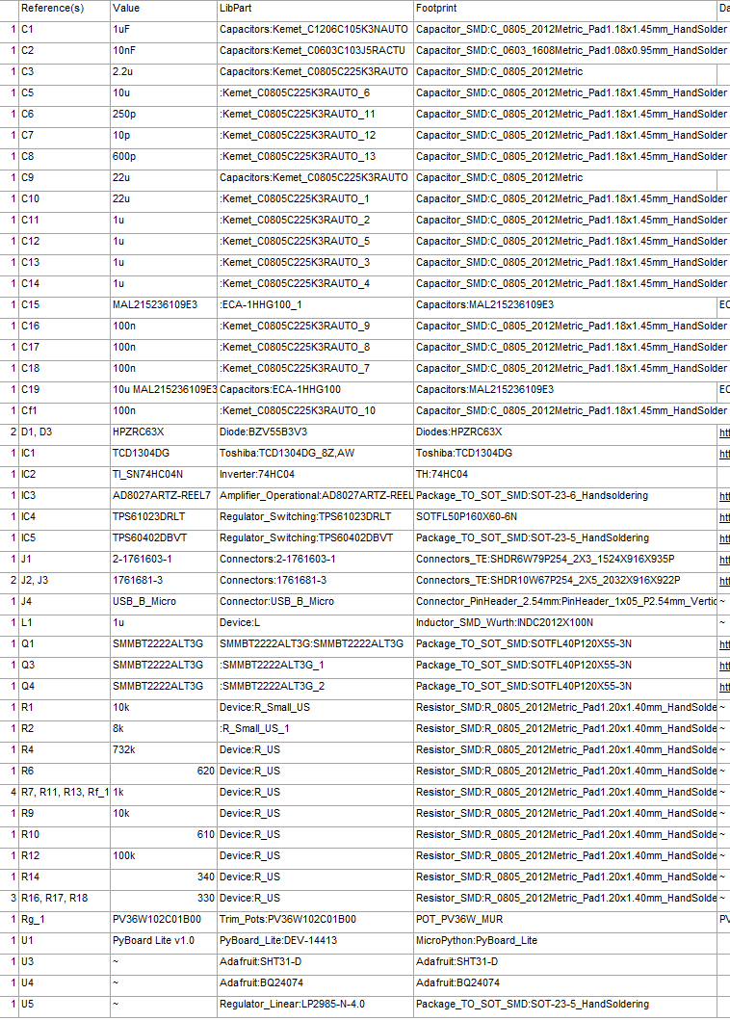

Project Management

Work Breakdown Structure
Our work breakdown structure includes details such as the activities, descriptions, deliverables, durations, due dates, assigned personnel, resources, and milestones. We also documented some prerequisite tasks before starting a new one. Some of the milestones included are hardware design prototype, multidisciplinary integration, evaluation, poster submission, and undergraduate presentations. We have determined that programming and hardware design will take the longest duration followed by testing and calibration. Currently we are slightly ahead of schedule, which allows us extra time for the final design of the printed circuit board as well as testing.

Gantt Chart
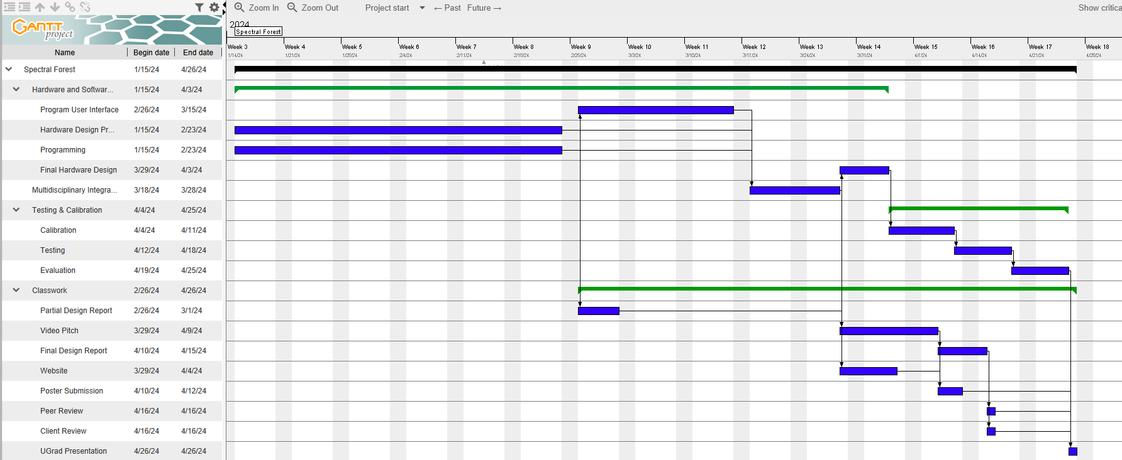

The Gantt chart indicates the activities that need to be completed as well as the activities that depend on others. As we can see on the chart, hardware prototype can be done at the same time as the programming. The programming and hardware prototype need to be completed before we can start on the user interface as well as get the partial report. Once the user interface is complete, we can start the multidisciplinary integration which is where we combine the mechanical structure and the electronics. Once the integration is completed, we are then able to design the final hardware design, video pitch, and update the website. Once the final hardware design is complete, we started the testing and calibration part of the project, which involved testing the final design and calibrating the light spectrum on the TCD1304DG. Once testing and calibration are complete, we will be able to start the evaluation to understand if there are any necessary changes to the program. Once the evaluation is complete, we will be able to present the work at UGrad.

PERT Chart
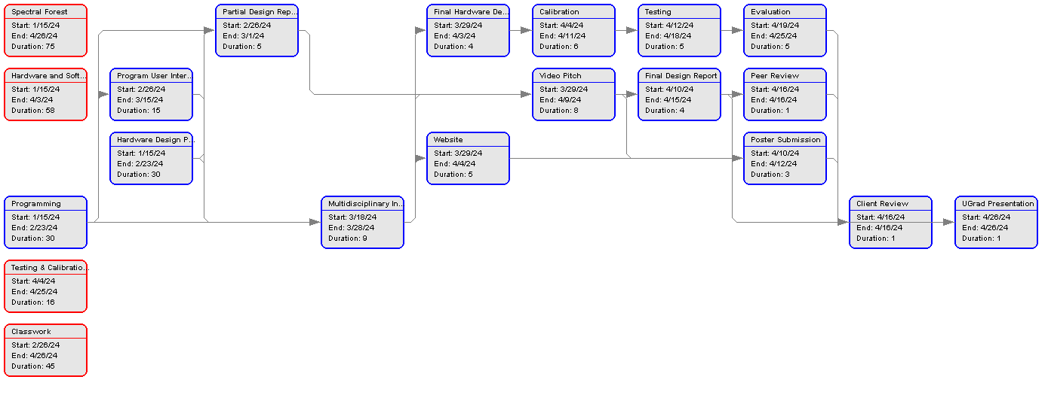
The PERT chart is an illustration of the Gantt chart description above. It focuses on what tasks need to be completed before other tasks can be started. It also tells us the expected duration of each task. It will be essential to stay on track to complete the project before the April 26 deadline. For example, once the partial report has been submitted in Canvas we can begin updating the website.

Testing
The construction of the main script was completed in a modular fashion. Each section of the code was developed individually and then tested. Once each section of code had been validated it was added into the compilation of modules that constitutes the main program loop. During this process, sections of the code that were working independently did not always work as intended when fit within the main loop of the program. Generally, the solution to code that was working independently, that fails in the main loop, just comes down to placement within the code. Some variables that store sensor values are prime examples of variables that need to be placed correctly so they refresh during consecutive readings. Another hard-won realization is that the only way to successfully write and save data is to perform a hard reset via the machine.reset() command. A simple solution that caused several weeks of confusion and troubleshooting.
The table below shows the ten accelerometer readings stored on the micro-SD card.
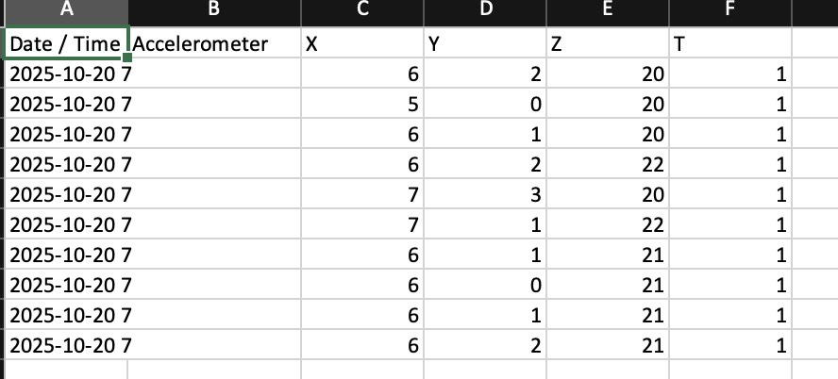

The table below shows the Temperature, Percent Humidity, and Integration Level
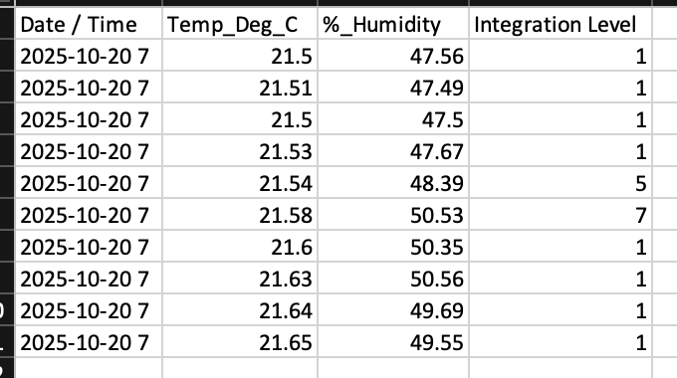

A good amount of time was spent formatting data to correctly store in the pre-allocated data files. The main goal of the spectrometer is to store spectral data, but along with these data points the device will also store environmental conditions collected from within the optical compartment. Accelerometer data is also collected to provide orientation information. The spectrometer will be deployed via drone, and the accelerometer will give a basis for the angle that the exposure was taken at. The CSV writing function was written from scratch. This is due to the lack of a preexisting library compatible with Micropython.
Initially testing the write and save functionality was done to the onboard memory in the ARM processor, but ultimately a 128GB micro-SD card will be used as the mass storage device. Initial attempts to save to the micro-SD card were unsuccessful. This held true for a while, and ultimately several micro-SD cards were used until one of them eventually worked. It was eventually determined that the formatting was the issue. For the MicroPython driven PyBoard, the micro-SD card must be formatted in the universal FAT type formatting.
A large amount of testing was centered around trying to break the main loop. Exception handling for typos or incorrect entries will not crash the program. The program will stay within while loops until a successful entry has been entered. The script was also tested on different devices and different operating systems. The program runs without issue on MacOS and Linux. Currently no tests have been conducted on Windows machines. The requirements for this project specified Linux as the preferred operating system, which is also the platform used for programming the PyBoard and all the foundational tests.
An auto integration function has been built in as an option to dynamically control the integration exposure time of the Toshiba TCD. Tests were completed to prove the concept as a viable solution to optimizing exposure times during varying conditions. Further testing must be done in situ to dial in the nine preset exposure times. We can ballpark these settings now, but we will need the full optical assembly to be completed to find the true nominal settings for the opto-electrical system.

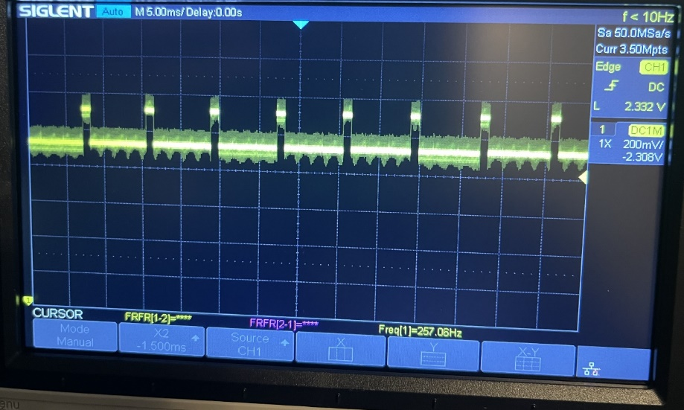
Figure 1: The image shown to the left is an output signal on the oscilloscope. The output signal shows dummy pixels.

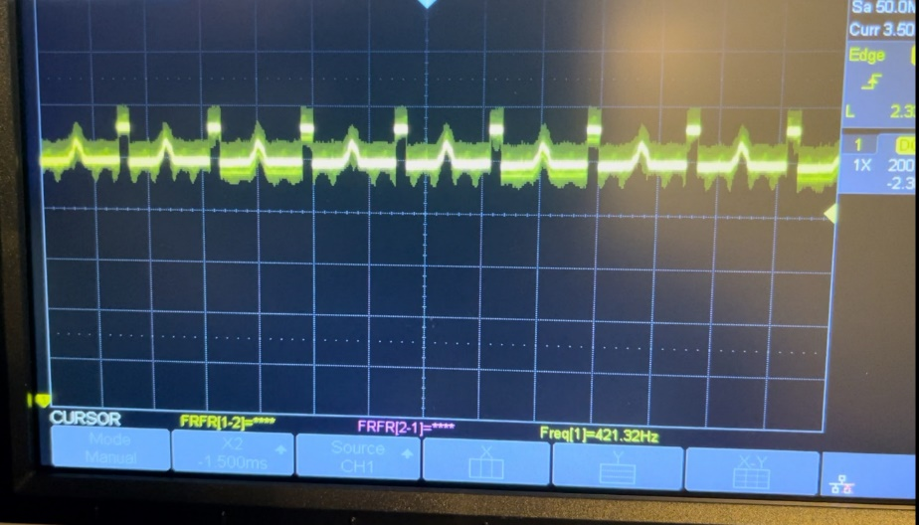
Figure 2: The output signal shows a peak which indicates a value being generated. The peak is created by blocking light to the TCD1304DG.

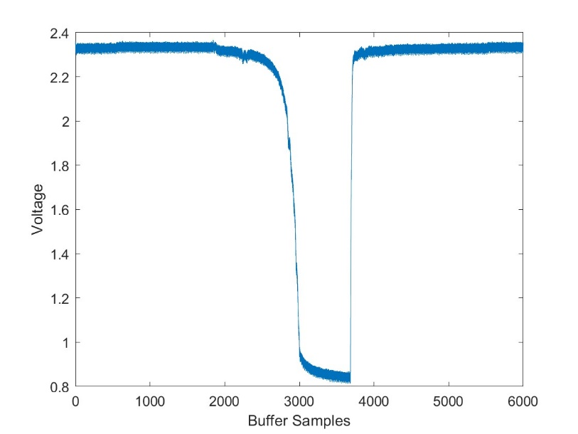
Figure 3: Spectrometer Data Collected: Sample from TCD1304DG in dark box and light generated with laser graphed in MATLAB.

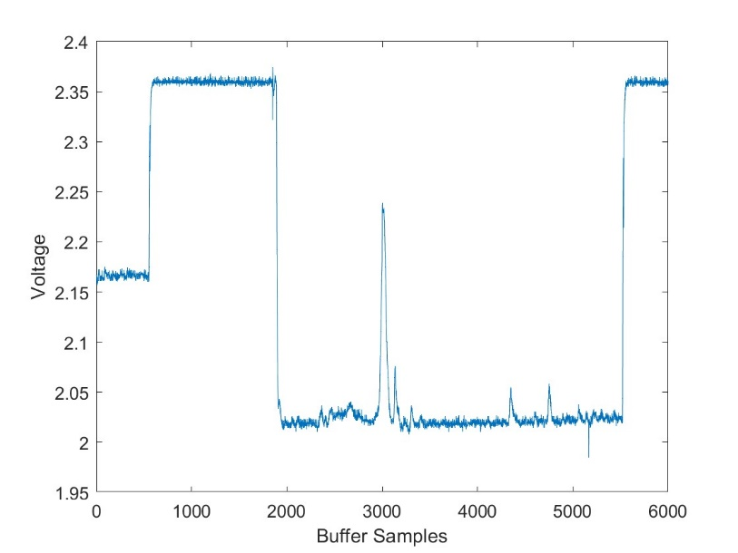
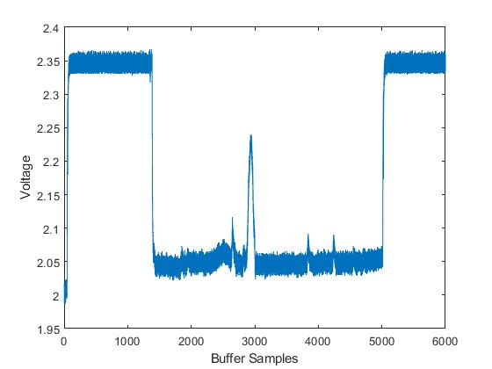
Figure 5: Spectrometer Data Collected: Sample from TCD1304DG output signal with an increase of light graphed in MATLAB.

Figure 4: Spectrometer Data Collected: Sample from TCD1304DG output signal graphed in MATLAB.

Test Matrix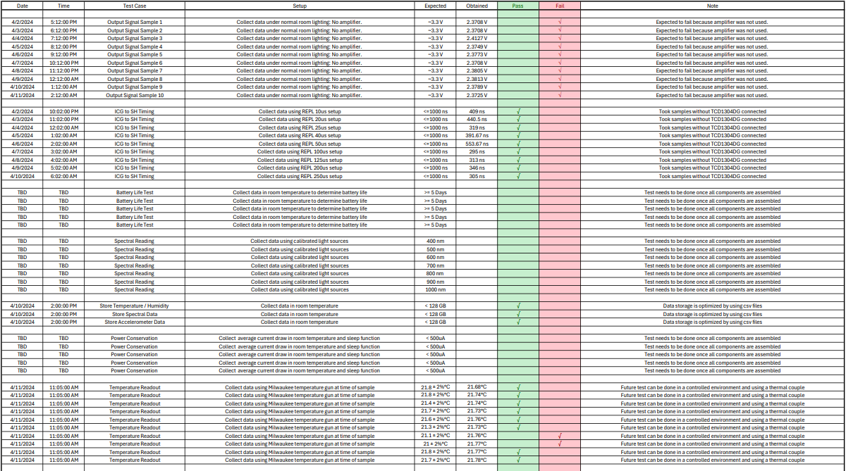

Conclusion
The hardware prototype and programming are about complete and the next steps that the team needs to focus on are the user interface, integration, final hardware design, testing, calibration, and final evaluation of the project. The first revision of our custom PCB is expected to have some issues that need to be worked out. Ordering early in the process will allow us to have time to fix any issues and order the final revision of the PCB. We are expecting to start working closely with the mechanical engineering team to get the structure, optics, and electronics working together. This will be done as soon as the PCB is manufactured. Once the integration has been completed, our team will further focus on the calibration and testing of the system. This should be enough time to make changes to the PCB if needed. The project is progressing well, and we should have enough time to finish the design before the deadline.

References
[1] Curious Scientist, “TCD1304 linear CCD - driving the CCD,” Curious Scientist, https://curiousscientist.tech/blog/tcd1304-linear-ccd-driving-the-ccd (accessed Mar. 1, 2024).

